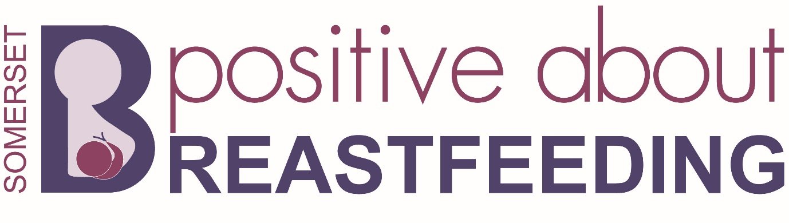
This venue welcomes babies to be breastfed in any public areas of these premises.

How we will make this happen:
All our staff will be encouraged to support the needs and rights of mothers breastfeeding. Any objections or challenges should be referred to INSERT NAME
A copy of this policy should be available to all new staff members and a copy available from INSERT WHERE
If a member of staff feels they need more guidance on this, they should speak to INSERT NAME

Our staff will:
• display stickers and appropriate signage
• make mothers and babies welcome

We are positive about breastfeeding:
We support the needs of families, including babies, and are more family friendly:
- Breastfeeding is the natural way to feed your baby.
- Breastfeeding supports Giving Every Child the Best Start in Life.

